Problem Statement 1: The Case and the Evidence
> The Scenario: You are a detective investigating a case where a hidden message is embedded
within a seemingly ordinary text file. This message could be crucial evidence!
> The Evidence: You will be provided with two files:
. innocent_text.txt: This file contains the text with the hidden message.
. message_to_find.txt: This file contains the hidden message you need to locate.
- Naïve Search :
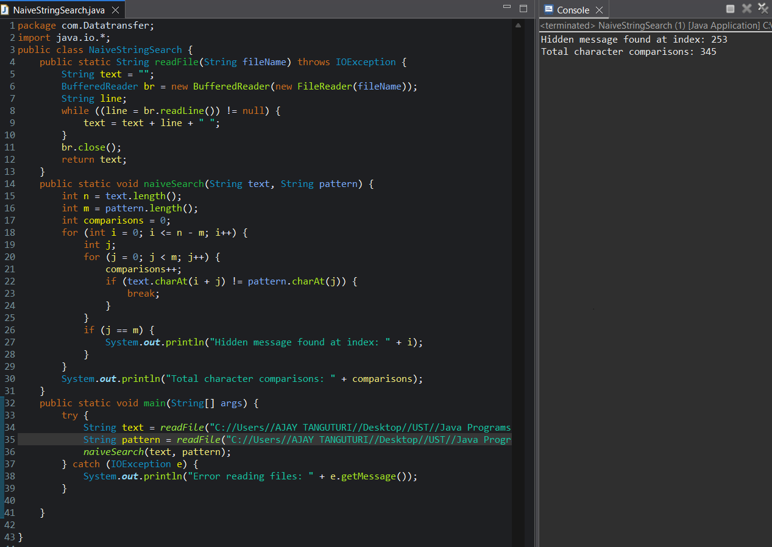

- Boyer – morre algorithm :
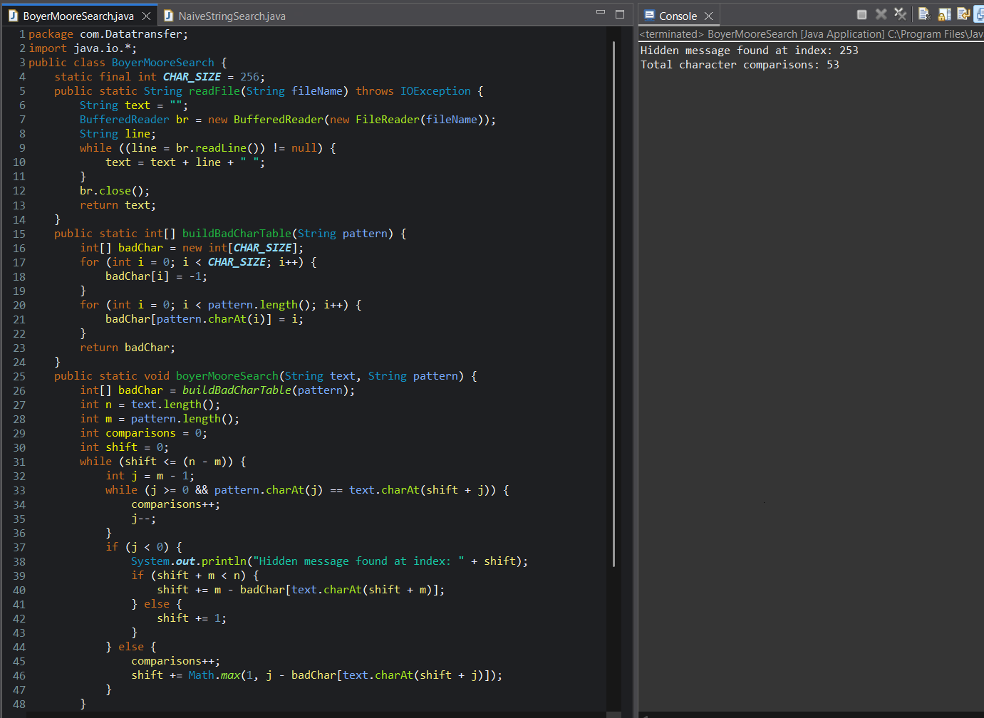

- Expanding the information
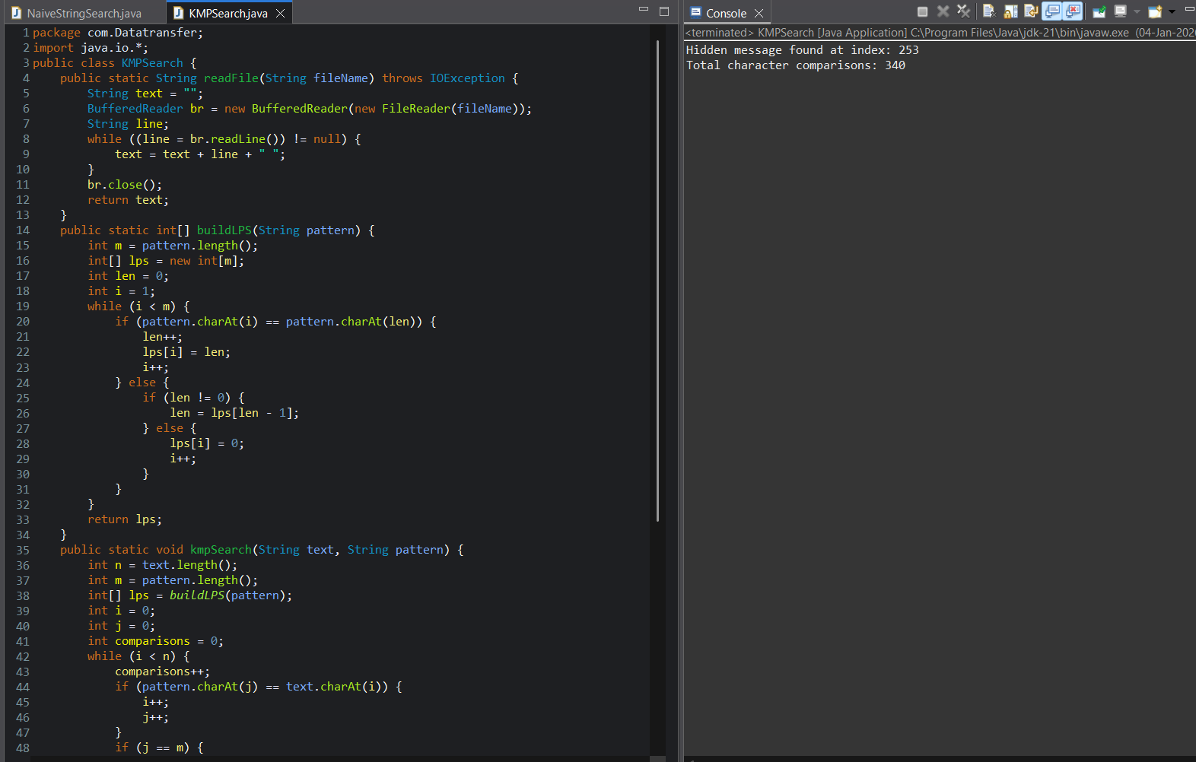

The Best and Worst time complexities for the all 3 algorithms
- n = length of text
- m = length of pattern
Algorithm | Best Case | Average Case | Worst Case
Naive Search | O(n) | O(n × m) | O(n × m)
Boyer–Moore | O(n / m) | O(n) | O(n × m)
KMP | O(n) | O(n) | O(n + m)

The worst case is rare boyer moore algorithm

- Un masking the message – the detective’s conclusion

Objective: Based on the results from your String Matching Algorithms, identify the hidden
message within the text file.
Task:
- Analyze the outputs from each algorithm.
  - Naive String Matching Algorithm
- The algorithm compared the pattern character-by-character at every possible position in the text.
- It successfully detected the hidden message after checking multiple overlapping positions.
- However, it performed a large number of character comparisons, especially before reaching the correct match.
Result:
  - Hidden message found successfully
  - Index position identified correctly
  - High comparison count observed
  - Boyer–Moore Algorithm
- The algorithm compared characters from right to left and used the bad character heuristic to skip unnecessary checks.
- When mismatches occurred, the algorithm skipped multiple characters instead of shifting by one position.
- This significantly reduced the number of comparisons.
Result:
- Hidden message found at the same index as Naive Search
- Very few character comparisons
- Fastest execution among all algorithms

  - Knuth–Morris–Pratt (KMP) Algorithm
- The algorithm preprocessed the pattern using the LPS (Longest Prefix Suffix) array.
- After mismatches, it avoided rechecking already matched characters.
- Performance was consistent and predictable.
Result:
- Hidden message found at the correct index
- Comparisons reduced compared to Naive Search
- Slightly slower than Boyer–Moore but more stable
Location of the Hidden Message
- The hidden message was found successfully by all three algorithms
- The starting index position of the hidden message was the same across all algorithms
- This confirms the correctness and consistency of the implementations
Efficiency Comparison
Algorithm | Comparisons | Efficiency
Naive Search | Very High | Least Efficient
Boyer–Moore | Very Low | Most Efficient
KMP | Moderate | Efficient & Stable

Challenges Faced During Implementation
- File Handling
  - Reading multi-line text files while preserving spaces required careful concatenation.
- Index Management
  - Ensuring correct index calculation after shifts (especially in Boyer–Moore) was tricky.
- Pattern Preprocessing
  - Constructing the LPS array in KMP required precise logic to avoid infinite loops.
- Comparison Counting
  - Accurately counting character comparisons for fair comparison needed careful placement.

